CURRICULUM VITAE
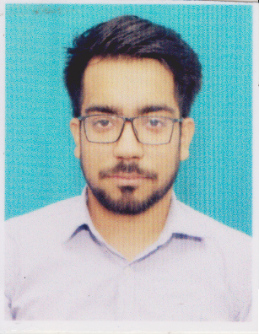
NAME: Rishabh Pathak

CORRESPONDENCE
ADDRESS : Modern Boys Hostel, Nazirabad Road,
Kolkata-700150
CONTACT NO.: +91 7596 986 226
WEBSITE: https://github.com/rishabhpathak09/
EMAIL ID: rishabh.pathak.cse20@heritageit.edu.in

CAREER OBJECTIVE:
To work as a full time Software developer by applying my coding skills, and by my leadership skills along with hard work and never give up attitude; contribute to this modern industry and help the company to set new standards with my team

ACADEMIC BACKGROUND:
- Pursuing Bachelor of Technology with specialization in Computer Science Engineering from Heritage Institute of Technology- Kolkata in Batch of 2016-2020 with CGPA of 8.77(in average) for 5 semesters

- Cleared AISSCE in the year 2015 from Durgapur with 80% of aggregate marks

- Completed CBSE 10th Board examination from Durgapur with 9.0 CGPA

PROFESSIONAL TRAININGS:
- Trained at ORACLE certified course for Android Application Development under Gagandeep Thakur as trainer.

CO-CURRICULAR AND EXTRA-CURRICULAR ACTIVITIES:
- Presented on an innovative technical idea in TECHNOVATION-2016 and achieved 2nd prize and participated in technical contests of technical fest Dakshh 2017 and in technical contests of technical fest TECKNOVATION-2018 and reached second round of Tech-Quiz
- Debater in Heritage Debating Society from year 2017 and Participated in JUMUN as Delegator held in Jadavpur University, Heritage Parliamentary Debate as Volunteer and Swing debater, in Colloquium as participant.
- Active teacher for economically backward students under Rotaract Club of HIT-K

- Active participant in the Resonance Club of Heritage from 2016

COMPUTER PROFESSIONAL:

C * * * *
Java * * * *
Python * * * *
SQL * * * *

JavaScript * * *
Android Studio * * *
HTML * * *
CSS * *
C++ * *
Node.js * *
XML *

Others- VHDL, PowerPoint, Excel, Word, Data Structures etc.

PERSONAL PROFILE:

DOB: 29th September, 1997
FATHER'S NAME: Umesh Pathak
ADDRESS: c/o J.K. Pathak, Near Airtel Tower, New Diwakar Road, Roydanga, Durgapur-713201
NATIONALITY: Indian
LANGUAGES KNOWN: Hindi, English and Bengali
INTERESTS: Singing, travelling new places, cricket, photography, painting

